**Lab 2: Conditional statements, Loops and Arrays**

If you can download the GCC compiler in Ubuntu use that – otherwise use a linux c compiler of your choice

Question 1 : **Vi Editor**

Refresh your memory of the VI editor:

Good resource: The [VI Help Sheet](http://www.smashingmagazine.com/wp-content/uploads/2010/05/VI-Help-Sheet-011.pdf) and webcourse link *the VI Editor*

* Create a file called Betty using vi. The original contents of this file are

*Betty bought a bit of butter, but the bit of butter Betty bought was bitter. So Betty bought another bit of butter.*

* Next copy the above piece of text and make the following changes.
* Using vi in *command line mode* Copy and Paste this test both before and after the original test (look up the internet if you require help)
* Replace Betty with Mary- Butter with Batter and bitter with better. :%s/Betty/Mary/g
* Save the file
* Using linux shell commands: (hint:” synonym for toilet”)
  + Determine the number of lines in a file
  + determine the number of characters in the phrase

Q2 Write a program using **functions** to determine if an array of the size of your choice (5, 6..

The main function must input the data; display the results of the 3 functions.

* The sum of the contents of the array;
* The max and min values in the array
* whether an array of **ints** is symmetrical. That is, its first element of array 1 is the same as its last element of array 2, its second element is the same as its next-to-last element etc.(hint: conditions for incrementing p (index of array 1) and de-incrementing j (index of 2nd array) are
  + *p<MAX && j>=0 && p < j && array[p] == array[j]*

while( i != Arr_SIZE)

{

if (array[i] == array_2 [arr_size - 1 - i])

{

count++;

}

if (min > array[i])

{

min = array[i];

}

if (max < array[i])

{

max = array[i];

}

sum_of_arr += array[i];

i++;

}

if (count == arr_size)

{

puts("The array is symmetrical");

}

else

{

puts("The array is not symmetrical");

}

printf("The min of the set of numbers is %d and the max\

is %d, as well as the total is %d",min,max,total);

Q3

i) Using comments describe what the following piece of code represents

**int i=3; // declare a variable I and assign it the value 3  
int *j;  
int **k;  
j=&i;**

**k=&j;**

Given the above variable declaration what output will arise from the following code.

**printf(“ the value of i is %d the address of i is %p”, i , &i)**

**printf(“ the value of j is %d the address of j is %p”, j , &j)**

**printf(“ the value of k is %d the address of k is %p”, k , &k)**

**printf(“%d”, **k);  
printf(“%d”,*j);  
printf(“%d”,i);**

Write a c program, using vi editor and the gcc compiler, to see if your answers are correct.

Additional Question

Q4

1. Using the notes covered in class write a program that will:
2. Declare 2 3x3 matrices (you can hard code the values into each matrix (2_D array)
3. Multiply the matricies assigning the result to a third 2_D array

You can use the following example to demonstrate if your program is correct:

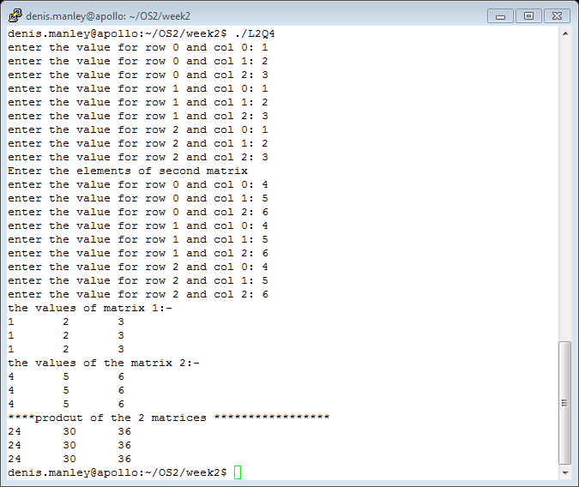

int array_1 [3][3], array_2 [3][3], product[3][3];

for (int i = 0; i < 3; i++)

{

for (int j = 0; j < 3; j++)

{

array_1 = random(0,10);

array_2 = random(0,10);

}

}

puts("The values for matrix one are:");

for (int i = 0; i < 3; i++)

{

for (int j = 0; j < 3; j++)

{

printf("row: %d col: %d\t%d\n",i,j,array_1[i][j]);

}

}

puts("The values for matrix two are:");

for (int i = 0; i < 3; i++)

{

for (int j = 0; j < 3; j++)

{

printf("row: %d col: %d\t%d\n",i,j,array_2[i][j]);

}

}

for (int i = 0; i < 3; i++)

{

for (int j = 0; j < 3; j++)

{

for (int k = 0; k < 3; k++)

{

product[i][j] += array_1[i][k] * array_2[k][j];

}

}

}

puts("The values for product array are:");

for (int i = 0; i < 3; i++)

{

for (int j = 0; j < 3; j++)

{

printf("row: %d col: %d\t%d\n",i,j,product[i][j]);

}

}